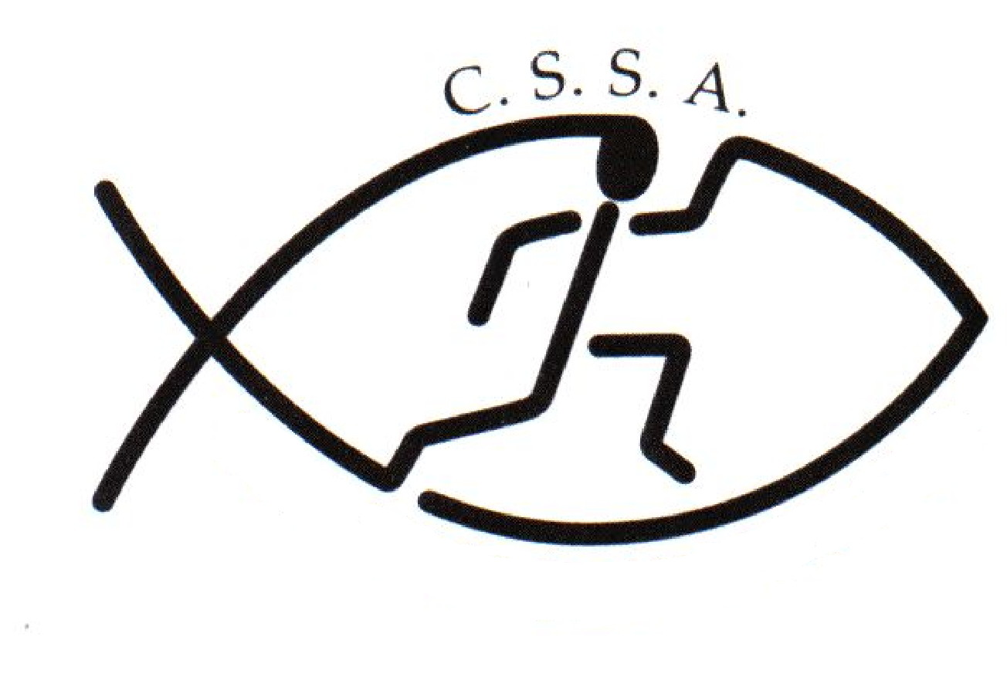
Risk Assessment Hazard Checklist – Student Activities
Event | CSSA Esports Rocket League Tournament | Assessment Date | 6 Oct 2021
Assessed By | Linda Heslehurst | Date | 7 & 8 October 2021

Locations | On-line | Activities | Esports Tournament
 |  |  | 2 days

CONSEQUENCE OR IMPACT
Level | Descriptor | Example detail description
1 | Insignificant | No injuries, low financial loss
2 | Minor | First aid treatment, on-site release immediately contained, medium financial loss
3 | Moderate | Medical treatment required, on-site release contained with outside assistance, high financial loss
4 | Major | Extensive injuries, off-site release with no detrimental effects, major financial loss
5 | Catastrophic | Death, toxic release off-site with detrimental effect, huge financial loss

LIKELIHOOD
Level | Descriptor | Description
A | Almost Certain | Is expected to occur in most circumstances
B | Likely | Will probably occur in most circumstances
C | Possible | Might occur at some time
D | Unlikely | Could occur at some time
E | Rare | May occur only in exceptional circumstances

RISK ANALYSIS MATRIX – LEVEL OF RISK
Likelihood | Consequences
 | Insignificant  1 | Minor  2 | Moderate  3 | Major  4 | Catastrophic 5
A (almost certain) | H | H | E | E | E
B (likely) | M | H | H | E | E
C (moderate) | L | M | H | E | E
D (unlikely) | L | L | M | H | E
E (rare) | L | L | M | H | H

Legend
E: extreme risk; immediate action required
H: high risk; senior management attention needed
M: moderate risk; management responsibility must be specified
L: low risk; manage by routine procedures

Exposure | Current Controls | Assessment |  |  |  |  | Additional Controls Required
 |  | Severity | Likelihood |  | Risk Priority
GENERAL
Supervision - not  Supervising all teams  adequately | All competing teams must have a teacher/staff member supervising them throughout the entire tournament | 3 |  | C |  | M | Schools must take into account such factors as age, experience, maturity of students, nature of the activity and experience of adult supervisors when arranging supervision and instruction.  Where an adult other than a teacher is engaged to provide instruction, a teacher must be take overall responsibility.
People & organisational hazards  Lack of information, training or instruction | Information relating to the CSSA Esports Tournament. ie. rules/regulations have been sent out to all CSSA schools via email. This information can also be obtained from the CSSA website: www.cssa.net.au | 2 |  | D |  | L | CSSA schools are required to have a full understanding & abide by the following policies which can be downloaded from the CSSA website: https://www.cssa.net.au/policies-a-forms.html  - CSSA Code of Conduct  - CSSA Child Safety Policy  - Safety in Sports Guidelines  https://www.cssa.net.au/sports-safety-guidelines-2.html  Schools are responsible for the preparation of students to an acceptable standard & have a good understanding of the rules/regulations & platforms being used prior to the tournament.
Poor activity planning or preparation  Poor activity delivery or organisation  Ignorance of rules and/or procedure  Unsafe behaviour or attitude  Poor safety control from group leaders  Poor safety awareness from participants | The convener has considerable experience organising Esport Tournaments and leading groups in similar environments. The CSSA Esports Tournament will be coordinated Mr Zac Latham & Yonder Esports. zac@yonderesports.com.au | 2 |  | D |  | L | The program Toornament will be the platform used for fixtures & results  https://www.toornament.com/en_GB/  School team coaches/manager are responsible for ensuring their school team members have accounts setup prior to the tournament
Referees/Officials with inadequate knowledge for effective supervision | Use of a specialised Esports staff from Yonder Esports | 2 |  | D |  | L | Schools are responsible for ensuring that school staff are competent & understand rules/safety requirements of the event they have been allocated to run.
Staff unfamiliar with emergency management principles | As it is a virtual event, schools are to ensure students know and understand the procedures for their school prior to the day. | 2 |  | D |  | L
Employees without Working with Children Checks | All staff present at the event are understood to have undergone Working with Children check by the venue, Officials, Association, or individual school. | 2 |  | C |  | M | Schools are responsible to check WWCC of their staff, parents & volunteers
Transport to and from the ESports Tournament | Responsibility is with the student’s school and / or parents to get them to venue. No external venue required. | 2 |  | C |  | L
Student Supervision when not competing | Schools are responsible for their supervision of their students throughout the entire tournament | 2 |  | C |  | M
Food Poisoning & Dehydration | Students are recommended to bring their own lunch, snacks and drinks for the day. Students are recommended to take regular breaks & drink plenty of water to avoid dehydration | 2 |  | D |  | L | Purchasing food at school or other external outlets is done at their own risk.
PARTICIPANTS / SPECTATORS
Inadequate training and preparation of students/competitor  Low level of physical fitness / strength | Responsibility of each school to prepare students/competitors. | 2 |  | D |  | L
Physical injury/ asthma attack etc. because of participation | If students are asthmatic, they must always carry their medication. | 2 |  | C |  | M | Each school is required to have a First Aid Kit on hand & the supervising teacher /coach must have 1st Aid training
Student injury ie. wrist injuries caused by repetitive strain, vision issues, mental fatigue, burnout | Tournament games will be played in 30 minute blocks | 3 |  | B |  | M | The convenor will remind & encourage students throughout the day to stand up, walk around the house, stretch, and get a drink of water or a snack between games. Esports should not mean that we don't focus on proper health.  Supervising teacher are to remind & encourage their students to do this also.
Students inappropriately dressed to compete. ie. uniform, footwear | Students are to be dressed appropriately for the event. Individual schools must check that their students are appropriately dressed to compete, preferably in school uniform or school sports uniform. | 2 |  | C |  | M
OFFICIALS / PROGRAM
Poor program/draw organisation | The program has been arranged to maximise efficiency and safety of participants.  Toornament will be the platform used for fixtures & results  https://www.toornament.com/en_GB/ | 2 |  | D |  | L | Games will be allotted into 30 minute blocks. A game of rocket league will only take around 10 minutes per game. 30 minute blocks will allow students time to stand up, walk around, stretch and get a drink of water or a snack. Our focus whilst competing in the Esports tournament is on good health practises.
EQUIPMENT / GROUNDS
Failure to check competition areas/venues and equipment prior to event | School staff are required to check competition area, computers/headsets etc prior to competition. | 2 |  | C |  | M
ENVIRONMENTAL
Online bullying, bad language & hate speech | Discord has been chosen as the chat App.  A private server has been created on Discord by the Convenor which will allow all CSSA students/teachers to join via a secure link - people outside of the tournament CANNOT communicate with the students.  The following information has been provided for schools, students & parents to help teens stay safe on Discord  https://discord.com/safety/360044153831-Helping-your-teen-stay-safe-on-Discord | 2 |  | C |  | M | Yonder Esports have programmed a host of bots on the server to automatically filter out any bad language and/or hate speech  Yonder Esports have also disabled students being able to direct message any students/teachers and we can also send through a video tutorials on how teachers/parents can turn off direct messages on their child's account.
Unsafe on-line environment | All teams entering the tournament are required to have a teacher/adult supervising them during the tournament | 2 |  | C |  | M | Yonder Esports will have a number of moderators who will be monitoring & recording the chat during the tournament  Only parents and or the school should create a Discord account for students which they can monitor. At the end of the tournament the Discord account should be deleted
Risk of spread of COVID-19 | Schools are to download and follow the CSSA COVID Safety Plan which can be found on the CSSA website: www.cssa.net.au | 5 |  | D |  | M | Schools are to also follow their own school COVID Safety Plan

CSSA does not provide Personal/Accident Insurance Cover

As a competing school we are aware that all teachers/parents/volunteers that we send to a carnival or sporting event have
completed a “Working with Children” prohibited employment form

Change Rooms

CSSA recognises that children are particularly vulnerable in change rooms and that measures must be put in place to ensure that children are able to safely get changed without fear of intrusion or fear for their safety.

Generally, the expectation of CSSA is that Member School Staff and Member School Volunteers would appropriately supervise change rooms in accordance with NSW Department of Education guidelines. The same goes for CSSA Staff and CSSA Volunteers who may be required to supervise change rooms in the course of supervising CSSA Representatives at Non-CSSA Events.

Those guidelines are that change rooms should be supervised and supervisors should adhere to the following guidelines:

- give explicit instructions and guidelines for behaviour in change rooms
- set a routine for going into change rooms and keep to it
- announce to students when entering the change room and allow time for students to cover up, and
- do not stand in change rooms while students are changing as students have a right to privacy.

While the issue of a supervisor of either sex supervising the change rooms of both sexes poses some difficulties, some suggestions for supervisors in this situation include:

- give explicit rules about what is expected of students' behaviour in the change rooms
- ensure that students know that if there is an emergency you will enter the change room
- choose two student representatives to report to you about any problems in the change rooms
- ask the students to come out of the change room if there is any disturbance
- if for some reason the students remain in the change room seek a person of the appropriate sex to go in, and
- if there is an emergency, let students know you are coming in and give a warning to cover up before going in.

Risk Warning under section 5M of the Civil Liability Act 2002 (NSW)
on behalf of CSSA and its Member Schools
Sporting Activities
Christian Schools Sports Association (CSSA) administers and convenes CSSA inter-school sporting activities in which many students from Member Schools participate. Students participating in these sporting events take part in practice, trials and competitions.

CSSA and its Member Schools expect students to take responsibility for their own safety during sporting activities by wearing compulsory safety equipment, by thinking carefully about the use of safety equipment that is highly recommended and by behaving in a safe and responsible manner towards team members, opponents, spectators, officials, property and grounds. CSSA and its Member Schools also expect parents, spectators and other participants to behave in a safe and responsible manner, to comply with the CSSA Code of Conduct and to set a good example for the students.

While CSSA and its Member Schools take measures to make the sporting activities as safe as possible for participants, there is a risk that students can be injured and suffer loss (including financial loss) and damage as a result of their participation in these sporting activities, whether at training or in actual events.

Parents, spectators and officials could also be injured or suffer loss.

Injury can occur while the student, parent, spectator or official is engaging in or watching a sporting activity, or travelling to and from the event. The injury may result from a student's actions, the actions of others, the state of the premises or from equipment failure.

On some occasions, an injury can be serious (such as torn ligaments, dislocations, back injuries, concussion or broken bones). In very rare cases an injury can be life threatening or result in permanent disability. If a student, parent, spectator or official has a pre-existing injury, participating in a sporting activity could result in an exacerbation of that injury.

Students, parents, spectators and officials could also suffer loss as a result of their personal property being lost, stolen, damaged or destroyed.

CSSA does not provide Personal or Accident Insurance Cover.

e-sports Date:

Level of Competition (tick appropriate) |  |  | Intra School |  | Inter School
Year level/s (tick appropriate)
 |  | Junior Primary (Yrs 3-4) |  |  | Senior Primary (Yrs 5-6)
Junior Secondary (Yrs 7-8) |  | Intermediate Secondary (Yrs 9-10) |  |  | Senior Secondary (Yrs 11-12)

General
 | Yes | No | NA
Permission has been obtained from parents/guardians for all students participating
Adequate teachers are attending providing appropriate levels of supervision for the activity.
Parents have been notified of location of venue, transport arrangements and time involved
First Aid Kit available
Water is available for students at the venue
Ice is available
Students have been advised of personal sun protection requirements
Students suffering from Asthma have been advised to carry their puffer to all events
Students suffering from anaphylaxis have been advised to carry their EpiPen to all events
Staff issued with first aid policy
Form provided for record of injuries/incidents
Access available for emergency vehicle
A Risk Assessment has been completed

Participants & Officials
Suitably qualified officials/teachers are to be used and are aware of rules and safety procedures at their event
Students wearing appropriate clothing and footwear to compete (school uniform)
Students have been made aware of guidelines for use of chess clocks
All attending are aware of emergency procedures and exits

Equipment / Grounds
The playing area has been checked and is free of obstructions and loose objects
Adequate facilities and shelter are available for spectators
All event areas and equipment have been checked for age appropriate weights and heights
Public facilities and buildings which are to be used have been checked

Environmental
Weather conditions appropriate for the safe conduct of the event if outdoors

COVID 19
COVIID 19 risk assessment downloaded and followed

