CSSA Football Finals - Risk Assessment Checklist
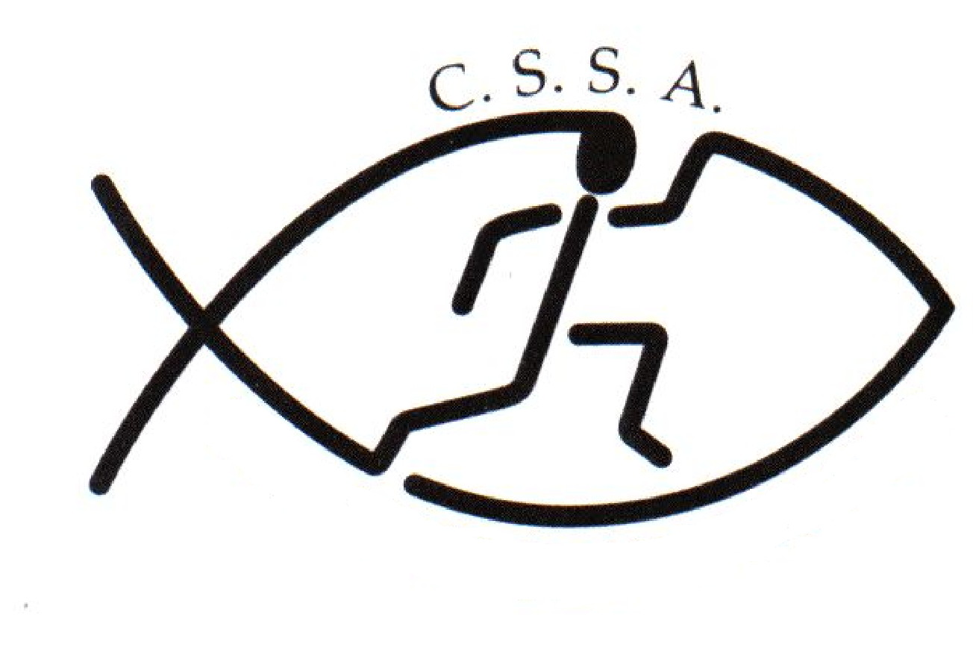
Football Championships | CSSA Football Trials |  | Assessment Date
Assessed By | Linda Heslehurst |  | Approved By | Linda Heslehurst  CSSA Executive Officer

Locations | Bernie Mullane Synthetic Football Fields |  | Activities | Football
 | Kellyville |  |  | Primary /Secondary Girls/Boys

1 | INDOOR HAZARDS |  |  | 5 | HAZARDS ON HILLS AND MOUNTAINS
1.1 | Inappropriate lighting |  |  | 5.1 | Slips & trips on grass, mud, rock
1.2 | Temperature |  |  | 5.2 | River crossings
1.3 | Insufficient or unsuitable space |  |  | 5.3 | Remote locations
1.4 | Untidiness – causing trip / fire hazard |  |  | 5.4 | Difficult communication – weather / distance
1.5 | Stairs – dark / steep / no handrail |  |  | 5.5 | Falling debris
1.6 | Lack of fire escapes / extinguishers / procedures |  |  | 5.6 | Extra work imposed by terrain type / angle
1.7 | Slip / trip / fall hazards |  |  | 5.7 | Lack of shelter
1.8 | Inadequate ventilation |  |  | 5.8 | Separation of group members
1.9 | Inhalation of dust |  |  | 5.9 | Getting lost
1.10 | Poor surfaces for activities – slips / trips / impact |  |  | 5.10 | Falls from height
1.11 | Electrical hazards |  |  | 5.11 | Extremes of weather
2 | SPORTING ACTIVITY HAZARDS |  |  | 6 | PEOPLE & ORGANISATIONAL HAZARDS
2.1 | Uneven playing surface | Y |  | 6.1 | Lack of information, training or instruction | Y
2.2 | Playing surface too hard or soft |  |  | 6.2 | Poor activity planning or preparation | Y
2.3 | Hard or sharp objects on pitch | Y |  | 6.3 | Poor activity delivery or organisation | Y
2.4 | Sliding on Astroturf or similar surface | Y |  | 6.4 | Ignorance of rules and / or procedures | Y
2.5 | Collisions / Conflict with surrounding objects or people | Y |  | 6.5 | Unsafe behaviour or attitude | Y
2.6 | Impact from sports equipment - Ball or Clubs | Y |  | 6.6 | Lack of appropriate first aid equipment and experience | Y
2.7 | Contact sport injury | Y |  | 6.7 | Medical conditions of participants | Y
2.8 | Personal injury – fracture / sprains / cuts | Y |  | 6.8 | Poor safety control from group leaders | Y
22.22 | USE BY UNTRAINED PERSONS NAUGHTY | YE |  | 6.9 | Poor safety awareness from participants | Y
3 | HAZARDS ON COASTS & COASTAL WATERS |  |  | 6.10 | Lack of cooperation within group | Y
3.1 | Falls from cliffs, piers, sea walls |  |  | 6.11 | Differing skill levels within group | Y
3.2 | Struck by falling objects from cliff |  |  | 6.12 | Low level of physical fitness / strength | Y
3.3 | Slips & falls on slopes / loose surfaces |  |  | 6.13 | Aggression between participants | Y
3.4 | Quick sand & mud |  |  | 6.15 | Aggression from crowd / public
3.5 | Access problems due to steep angle of beach slope |  |  | 6.16 | Contact between participants increasing risk
3.6 | Collisions between water users |  |  | 2.22 | USE BY UNTRAINED ERSONS NAUGHTY | ES
3.7 | Swept away by wave surges |  |  | 7 | EQUIPMENT AND OTHER HAZARDS
3.8 | Being washed against rocks / piers |  |  | 7.1 | Crash handling
3.9 | Low water temperatures |  |  | 7.2 | Transport to and from your activity | Y
3.10 | Communication problems from waves / swell / distance |  |  | 7.3 | Food poisoning | Y
3.11 | Struck by objects in water |  |  | 7.4 | Hazardous substances
3.12 | Stranded by tides |  |  | 7.5 | Equipment with moving / hot parts
3.13 | Swept away by currents |  |  | 7.6 | Heavy equipment – goal posts | Y
3.14 | Rip tides |  |  | 7.7 | Electrical hazards from equipment
3.15 | Longshore drift |  |  | 7.8 | Noise from equipment
3.16 | Conflicts between beach users |  |  | 7.9 | Risk of trapping body / clothing in equipment
22.22 | UNTRAINED PERSONS NAUGHTY | YE |  | 7.10 | Inadequate environment for equipment operation
4 | HAZARDS ON STILL / MOVING WATER |  |  | 7.11 | Inadequate protective equipment
4.1 | Getting swept away from equipment or people |  |  | 7.12 | Equipment in unsuitable condition
4.2 | Collision with rocks in and to sides of rivers |  |  | 22.2 | NAUGHTY | YS
4.3 | Striking / trapping by submerged obstacles |  |  | 8 | OTHER HAZARDS SPECIFIC TO YOUR ACTIVITY
4.4 | Being dragged down by undertow |  |  | 8.1 | Sunsense & Dehydration | Y
4.5 | Restricted or impossible access to / from water |  |  | 8.2 | Lightening | Y
4.6 | Access problems – rescue / getting kit into water |  |  | 8.3 | Extremes of weather | Y
4.7 | Falls from drops in level at weirs / waterfalls |  |  | 8.4
4.8 | Getting out of depth |  |  | 8.5
4.9 | Low water temperature |  |  | 8.6
4.10 | Separation from other people |  |  | 8.7
4.11 | Slips / trips on steep banks or uneven surfaces |  |  | 8.8
4.12 | Difficult communications |  |  | 8.9
4.13 | Remote locations |  |  | 8.10

Risk Assessment – Student Activities
Club/Society Name | Christian Schools Sports Association | Number of persons involved | Approx. 100
Nature of Activity | Football | Frequency of Activity | One day

Assessed By | Linda Heslehurst | Dates :

Hazard Ref. | Potential Effect | Existing Controls in Place | Score  Low/Medium/High Risk | Further Controls Required | Who By | When
2.1, 2.4, 2.8 | Uneven playing surface  Sliding on Astroturf  Personal injury – fracture / sprains / cuts | The State Football Finals will be played on outdoor synthetic &/or grass playing fields that are regularly checked & maintained by Hills Council. Players are required to wear adequate footware appropriate for the sport & surface type. Players are encouraged to strap their ankles & knees to help prevent sprains etc. Players are remindered that slide tackles on synthetic grass can lead to turf burns. All user groups to inspect fields before playing. | Low/Medium
2.3 | Hard or Sharp Objects on the Pitch | A safety & venue audit will be conducted prior to the commencement of play. Any sharp objects will be removed or a warning sign placed near any potential danger. | Low/Medium
2.5, 2.7 | Collisions/Conflicts | Players are required to conduct themselves in accordance with the rules of the game and CSSA Code of Conduct. Capable people/referees will be controlling each game. If injury does occur the state convener has her first aid certificate. | Medium
2.6 | Impact from sports equipment - Ball | Players are required to conduct themselves in accordance with the rules of the game and CSSA Code of Conduct. If injury does occur there is a qualified first aid trainer on hand. | Medium
6.1 | Lack of information, training or instruction | Information relating to the Football Trials/State Finals has been sent out to all participating CSSA schools via email. This information can be obtained from the CSSA website : www.cssa.net.au The CSSA Code of Conduct can also be downloaded from the website. Schools are expected to train their students to an acceptable standard of play & have a good understanding of the rules. | Low
6.2 | Poor activity planning or preparation | No specific leadership qualifications are normally required but the convener has previous experience of playing and organising football(Soccer) trials and of leading groups in similar environments. The trials will be coordinated by Amanda Butterworth: CSSA Assistant Executive Officer. | Low
6.3 | Poor activity delivery or organisation | The convenor will ensure that all students are briefed regarding: the rules and safety procedures laid down by CSSA. | Low
6.4, 6.5 | Ignorance of rules and / or procedures  Unsafe behaviour or attitude | CSSA Code of Conduct is clear as to expectations upon players/team managers/parents/peectators. All sports coordinators have agreed to abide by the Code of Conduct when they entered students . All players should be familiar with the code of conduct before attending the trials. The CSSA Code of Conduct can be downloaded from the CSSA website: : www.cssa.net.au | Low
6.6 | Lack of appropriate first aid equipment & experience | A qualified first aid trainer will be on hand. | Low
6.7 | Medical conditions of participants | Individual schools and associations to ensure their players are medically fit. | Low/Medium
6.8, 6.9 | Poor safety control from group leaders  Poor safety awareness from participants | Qualified referees are used. Coaches are experienced in team management | Low
6.10 to 6.12 | Lack of cooperation within group  Differing skill levels within group  Low level of physical fitness / strength | Players may cause an injury to themselves or others if they do not know how to play and are involved in a game situation with more experienced players All players are of a representative level and as such should be of a similar skill level. | Low/Medium
6.13 | Aggression between participants | Qualified referres to control the game within the laws. | Low/Medium
7.2 | Transport to and from your activity | Responsibility is with the students school and or parents. | N/A
7.3 | Food Poisoning | A canteen maybe available for students to purchase food & drink. All care has been taken to ensure proper control & handling procedurers are followed. Purchasing food at these outlets is done at their own risk. Players are recommended to bring their own food & drink to the venue. | Low/Medium
7.6 | Heavy equipment – goal posts | Ensure goal posts are in good working order and are properly secured | Low
8.1 | Sun Sense & Dehydration | All competitors are reminded to Slip, Slop, Slap before play commences & reapply through out the day. When not playing students are recommended to wear a hat. Informed that water should be carried. Drinks are available at the canteen and water is available from bubblers/taps. The venue has very little shade near the playing fields. Schools are advised to bring umbrellas & shade tents for their students to sit under when not playing.. | Medium
8.2 | Lightning | Players to be advised that at the first sign of local thunder or lightening they are to abandon the round and return to the club house immediately. Organisers to sweep the course to ensure compliance. | Low
8.3 | Extremes of weather | Co-ordinator will monitor playing conditions in relation to heat, storms and adverse playing weather. Event may be postponed, suspended or cancelled as required | Medium

CSSA does not provide Personal/Accident Insurance Cover

As a competing school we are aware that all teachers/parents/volunteers that we send to a carnival or sporting event have completed a “Working with Children” prohibited employment form

Change Rooms

CSSA recognises that children are particularly vulnerable in change rooms and that measures must be put in place to ensure that children are able to safely get changed without fear of intrusion or fear for their safety.

Generally, the expectation of CSSA is that Member School Staff and Member School Volunteers would appropriately supervise change rooms in accordance with NSW Department of Education guidelines. The same goes for CSSA Staff and CSSA Volunteers who may be required to supervise change rooms in the course of supervising CSSA Representatives at Non-CSSA Events.

Those guidelines are that change rooms should be supervised and supervisors should adhere to the following guidelines:

- give explicit instructions and guidelines for behaviour in change rooms
- set a routine for going into change rooms and keep to it
- announce to students when entering the change room and allow time for students to cover up, and
- do not stand in change rooms while students are changing as students have a right to privacy.

While the issue of a supervisor of either sex supervising the change rooms of both sexes poses some difficulties, some suggestions for supervisors in this situation include:

- give explicit rules about what is expected of students' behaviour in the change rooms
- ensure that students know that if there is an emergency you will enter the change room
- choose two student representatives to report to you about any problems in the change rooms
- ask the students to come out of the change room if there is any disturbance
- if for some reason the students remain in the change room seek a person of the appropriate sex to go in, and
- if there is an emergency, let students know you are coming in and give a warning to cover up before going in.

Risk Warning under section 5M of the Civil Liability Act 2002 (NSW)
on behalf of CSSA and its Member Schools
Sporting Activities
Christian Schools Sports Association (CSSA) administers and convenes CSSA inter-school sporting activities in which many students from Member Schools participate. Students participating in these sporting events take part in practice, trials and competitions.

CSSA and its Member Schools expect students to take responsibility for their own safety during sporting activities by wearing compulsory safety equipment, by thinking carefully about the use of safety equipment that is highly recommended and by behaving in a safe and responsible manner towards team members, opponents, spectators, officials, property and grounds. CSSA and its Member Schools also expect parents, spectators and other participants to behave in a safe and responsible manner, to comply with the CSSA Code of Conduct and to set a good example for the students.

While CSSA and its Member Schools take measures to make the sporting activities as safe as possible for participants, there is a risk that students can be injured and suffer loss (including financial loss) and damage as a result of their participation in these sporting activities, whether at training or in actual events.

Parents, spectators and officials could also be injured or suffer loss.

Injury can occur while the student, parent, spectator or official is engaging in or watching a sporting activity, or travelling to and from the event. The injury may result from a student's actions, the actions of others, the state of the premises or from equipment failure.

On some occasions, an injury can be serious (such as torn ligaments, dislocations, back injuries, concussion or broken bones). In very rare cases an injury can be life threatening or result in permanent disability. If a student, parent, spectator or official has a pre-existing injury, participating in a sporting activity could result in an exacerbation of that injury.

Students, parents, spectators and officials could also suffer loss as a result of their personal property being lost, stolen, damaged or destroyed.

CSSA does not provide Personal or Accident Insurance Cover.

SOCCER
( extract from the CSSA Safety in Sport Guidelines )

Where considered appropriate, for example inclusion in a school sport program, parents or caregivers must be informed of full details of the location, supervision to be provided and activities to be undertaken when seeking their written permission.
Students are to be instructed to use adequate sun protection, ego an SPF 15+, broad spectrum, water resistant sun screen reapplied regularly and a hat where appropriate.
TEACHER/INSTRUCTOR QUALIFICATIONS AND EXPERIENCE
The appropriate level of expertise and/or training required to conduct an activity will be dependenton whether the teacher's/instructor's role is one of supervision, instruction or coaching. Other factors to be considered are the nature of the activity, the age, ability and experience of the students involved. A teacher must be present who has recognised current emergency care training.

SUPERVISION
Where an adult other than a teacher is engaged to provide instruction, a teacher must be present to take overall responsibility.

It is recommended that qualified officials be used for inter-school competitions.

EQUIPMENT
Students must wear shin pads when boots are worn.

Students are to wear appropriate footwear such as soccer boots or sports shoes. If football boots are to be worn, no student should be permitted to play in any other type of footwear.

Boots must be inspected prior to the commencement of each game to ensure that studs do not have sharp edges or are excessively worn. Boots must conform to the rules of the game.

Goal posts and cross bars must be checked for stability prior to each game. Portable goal posts must be effectively anchored. Where possible, nets should be used.

Corner flags and other markers must be made of non-injurious material. A well-equipped medical kit must be readily available.

VENUES
The ground surface must be free of obstructions and loose objects. Hydrated lime should not be used to mark fields.

SAFETY
Students must remove jewellery and other ornaments likely to cause injury.

Spectators and non-participating players must be positioned at an appropriate distance from the field of play during the game.

Each school should have a coaching program based on conditioning and progressive skill training methods.

Warm-up and cool-down are vital elements in preventing injury and should be included before and after all training and competition sessions.

Stretching activities performed in the warm-up should move the muscles through the full range of movement to be performed during the session. The warm-up should be continuous and lead into the training session.

Where injury occurs during the game, the student must be excluded wherever there is any doubt as to the extent of injury or fitness to continue.

Teacher and coaches must exclude students from returning to playing after injury until it is clear that the student is fit to resume. If there is any doubt, the student is not to play until medically cleared.

Students must be made aware of the rules regarding dangerous play eg. tackling from behind, tripping and playing of the player, not the ball.
Where possible, ice should be available for the treatment of injuries.

INFECTIOUS DISEASES ("BLOOD RULE" PROCEDURE)
All clothing, equipment and surfaces contaminated by blood must be viewed as potentially infectious and treated accordingly.

A player who is bleeding must be removed immediately from the activity and not permitted to return until:
- the source of the bleeding has been controlled, the wound dressed and securely covered
- any blood covered body area has been cleaned thoroughly and any blood covered clothing or equipment has been cleaned or removed.

Football Risk Assessment

Level of Competition (tick appropriate) |  |  | Intra School |  |  | Inter School
Year level/s (tick appropriate)
Infants ( K-2) |  | Junior Primary (Yrs 3-4) |  |  |  | Senior Primary (Yrs 5-6)
Junior High (Yrs 7-8) |  | Middle High (Yrs 9-10) |  |  |  | Senior High (Yrs 11-12)

General
Permission has been obtained from parents/guardians for all students participating
Adequate teachers are attending providing appropriate levels of supervision for the activity and spectators.
Parents have been notified of location of venue, transport arrangements and time involved
First Aid Kit Available
Water is available for students at the venue
Ice is available
Students have been advised of personal sun protection requirements
Students suffering from Asthma have been advised to carry their puffer to all events
Staff issued with infectious diseases policy
Form provided for record of injuries/incidents
Access available for emergency vehicle
A Risk Assessment has been completed

Participants & Officials
Coaches are adequately experienced or qualified, details on file and have passed Child Protection checks
Suitably qualified referees are used
Teacher present with Emergency Care qualifications
Officials have checked players’ boots, jewellery, nails and shinpads prior to the match
Students are aware that properly fitted mouthguards are strongly recommended (mandated?)
Students have been instructed not to swing on goal posts

Equipment / Grounds
The grounds have been checked and are free of obstructions and loose objects.
Goals are checked for stability prior to game. Portable posts are effectively anchored
Spectator areas are clearly marked
Non hazardous line-marking material used
Corner posts/flags constructed to give way if a player collides with them e.g. cardboard
Public facilities and buildings which are to be used have been checked

Environmental
Weather conditions appropriate for the safe conduct of the event

