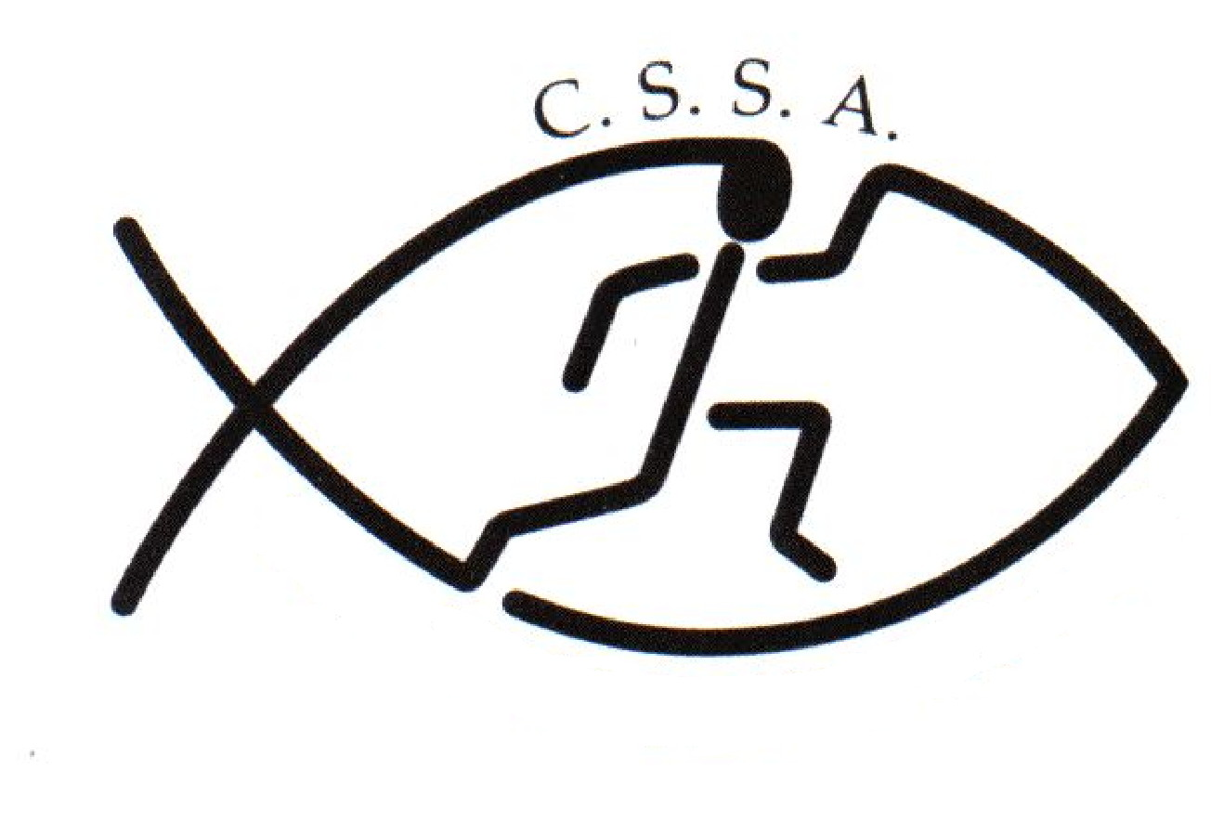
Secondary State Cricket Competition - Risk Assessment
CSSA Championships | CSSA Sec State Cricket Competition |  | Assessment Date
Assessed By | Linda Heslehurst |  | Approved By

Locations | TBC by schools entering competition |  | Activities | 20/20 Cricket & 50/50 One day Cricket

1 | INDOOR HAZARDS |  |  | 5 | HAZARDS ON HILLS AND MOUNTAINS
1.1 | Inappropriate lighting |  |  | 5.1 | Slips & trips on grass, mud, rock
1.2 | Temperature |  |  | 5.2 | River crossings
1.3 | Insufficient or unsuitable space |  |  | 5.3 | Remote locations
1.4 | Untidiness – causing trip / fire hazard |  |  | 5.4 | Difficult communication – weather / distance
1.5 | Stairs – dark / steep / no handrail |  |  | 5.5 | Falling debris | Y
1.6 | Lack of fire escapes / extinguishers / procedures |  |  | 5.6 | Extra work imposed by terrain type / angle
1.7 | Slip / trip / fall hazards |  |  | 5.7 | Lack of shelter
1.8 | Inadequate ventilation |  |  | 5.8 | Separation of group members
1.9 | Inhalation of dust |  |  | 5.9 | Getting lost
1.10 | Poor surfaces for activities – slips / trips / impact |  |  | 5.10 | Falls from height
1.11 | Electrical hazards |  |  | 5.11 | Extremes of weather
2 | SPORTING ACTIVITY HAZARDS |  |  | 6 | PEOPLE & ORGANISATIONAL HAZARDS
2.1 | Uneven playing surface | Y |  | 6.1 | Lack of information, training or instruction | Y
2.2 | Playing surface too hard or soft |  |  | 6.2 | Poor activity planning or preparation | Y
2.3 | Hard or sharp objects on pitch | Y |  | 6.3 | Poor activity delivery or organisation | Y
2.4 | Sliding on Astroturf or similar surface |  |  | 6.4 | Ignorance of rules and / or procedures | Y
2.5 | Collisions / Conflict with surrounding objects or people | Y |  | 6.5 | Unsafe behaviour or attitude | Y
2.6 | Impact from sports equipment - Ball or Clubs | Y |  | 6.6 | Lack of appropriate first aid equipment and experience | Y
2.7 | Contact sport injury | Y |  | 6.7 | Medical conditions of participants
2.8 | Personal injury – fracture / sprains / cuts | Y |  | 6.8 | Poor safety control from group leaders
22.22 | USE BY UNTRAINED PERSONS NAUGHTY | YE |  | 6.9 | Poor safety awareness from participants
3 | HAZARDS ON COASTS & COASTAL WATERS |  |  | 6.11 | Lack of cooperation within group
3.1 | Falls from cliffs, piers, sea walls |  |  | 6.12 | Differing skill levels within group
3.2 | Struck by falling objects from cliff |  |  | 6.13 | Low level of physical fitness / strength
3.3 | Slips & falls on slopes / loose surfaces |  |  | 6.14 | Aggression between participants
3.4 | Quick sand & mud |  |  | 6.15 | Aggression from crowd / public
3.5 | Access problems due to steep angle of beach slope |  |  | 6.16 | Contact between participants increasing risk
3.6 | Collisions between water users |  |  | 2.22 | USE BY UNTRAINED ERSONS NAUGHTY | ES
3.7 | Swept away by wave surges |  |  | 7 | EQUIPMENT AND OTHER HAZARDS
3.8 | Being washed against rocks / piers |  |  | 7.1 | Crash handling
3.9 | Low water temperatures |  |  | 7.2 | Transport to and from your activity | Y
3.10 | Communication problems from waves / swell / distance |  |  | 7.3 | Food poisoning | Y
3.11 | Struck by objects in water |  |  | 7.4 | Hazardous substances
3.12 | Stranded by tides |  |  | 7.5 | Equipment with moving / hot parts
3.13 | Swept away by currents |  |  | 7.6 | Heavy equipment
3.14 | Rip tides |  |  | 7.7 | Electrical hazards from equipment
3.15 | Longshore drift |  |  | 7.8 | Noise from equipment
3.16 | Conflicts between beach users |  |  | 7.9 | Risk of trapping body / clothing in equipment
22.22 | UNTRAINED PERSONS NAUGHTY | YE |  | 7.10 | Inadequate environment for equipment operation
4 | HAZARDS ON STILL / MOVING WATER |  |  | 7.11 | Inadequate protective equipment
4.1 | Getting swept away from equipment or people |  |  | 7.12 | Equipment in unsuitable condition
4.2 | Collision with rocks in and to sides of rivers |  |  | 22.22 | USE BY UNTRAINED PERSONS NAUGHTY | YS
4.3 | Striking / trapping by submerged obstacles |  |  | 8 | OTHER HAZARDS SPECIFIC TO YOUR ACTIVITY
4.4 | Being dragged down by undertow |  |  | 8.1 | Sunsense & Dehydration | Y
4.5 | Restricted or impossible access to / from water |  |  | 8.2 | Lightening | Y
4.6 | Access problems – rescue / getting kit into water |  |  | 8.3 | Extremes of weather | Y
4.7 | Falls from drops in level at weirs / waterfalls |  |  | 8.4
4.8 | Getting out of depth |  |  | 8.5
4.9 | Low water temperature |  |  | 8.6
4.10 | Separation from other people |  |  | 8.7
4.11 | Slips / trips on steep banks or uneven surfaces |  |  | 8.8
4.12 | Difficult communications |  |  | 8.9
4.13 | Remote locations |  |  | 8.10

Risk Assessment – Student Activities
Club/Society Name | CSSA | Number of persons involved | 400
Nature of Activity | Cricket | Frequency of Activity | Multiple days

Assessed By | Linda Heslehurst | Dates:
Location | TBC by schools entering competition | TBC by schools entering competition

Hazard Ref. | Potential Effect | Existing Controls in Place | Score  Low/Medium/High Risk
2.1, 2.8 | Uneven playing surface  Personal injury – fracture / sprains / cuts | The CSSA Secondary Cricket Competition will be played on outdoor playing fields. Schools entering the competition must ensure when booking the fields that they are regularly checked & maintained by the Council in charge of bookings. The playing surface can be uneven in spots. Players are required to wearing adequate footware appropriate for the sport & are encouraged to strap their ankles & knees to help prevent sprains etc. All user groups to inspect fields before playing. In regards to wet weather effecting the bowlers run-up, a descision will be made on the morning in conjunction with coaches as to whether games can be conducted safely. | Low
2.3 | Hard or Sharp Objects on the Pitch | A safety & venue check will be conducted prior to the commencement of play by the coaches of the teams involved in the days play. Any sharp objects must be removed or a cone placed near any potential danger. | Low/Medium
2.5  2.7  6.6 | Collisions/Conflicts | Players are required to conduct themselves in accordance with the rules of the game and CSSA Code of Conduct. Capable people/certified umpires are required to control each game. It is the responsibility of each school playing in the cricket competition (pool games & semi finals) to provide a capable or certified umpire on the day of play. Two professional umpires will be employed for the finals. If injury does occur schools are required to bring a 1st Aid Kit with them & ensure the supervising teacher is 1st Aid trained. | Medium
2.6  6.6 | Impact from sports equipment - ball, bat | Players are required to conduct themselves in accordance with the rules of the game and CSSA Code of Conduct. All teams are required to supply a full cricket kit containing proper fitting safety helmets with face guards, batting gloves and leg pads etc for the batters. The wicket keeper is required to wear protective gear including pads and gloves A recommendation has been made to all coaches that all batsmmen wear protective helmets, although this will be the responsibility of each coach to enforce. If injury does occur schools are required to bring a 1st Aid Kit with them & ensure the supervising teacher is 1st Aid trained. | Medium
5.5 | Falling debris | Due to the nature of the sport there will be very few trees at the cricket venues, however players MUST be instructed prior to the commencement of play not to stand under large trees – especially during a storm or high wind. The event will be cancelled in extreme weather conditions. | Low
6.1 | Lack of information, training or instruction | Information relating to the CSSA Sec Boys Cricket Competition ie. rules/regulations etc has been sent out to all CSSA schools via email. This information can be obtained from the CSSA website : www.cssa.net.au  The CSSA Code of Conduct can also be downloaded from the website. Schools are expected train their students to an acceptable standard of play & have a good understanding of the rules. | Low
6.2 | Poor activity planning or preparation | It is recommended that supervising teachers/coaches from each school have previous experience of playing and organising cricket matches and leading groups in similar environments. | Low
6.3 | Poor activity delivery or organisation | Team managers/coaches are expected to convey the rules and safety procedures laid down by CSSA onto their students prior to the commencement of play | Low
6.4, 6.5 | Ignorance of rules and / or procedures  Unsafe behaviour or attitude | CSSA Code of Conduct is clear as to expectations upon players/team managers/parents/peectators. All sports coordinators have agreed to abide by the Code of Conduct when they entered the competition. All players/team managers should be familiar with the code of conduct before playing any pool matches. The CSSA Code of Conduct can be downloaded from the CSSA website : www.cssa.net.au | Low
7.2 | Transport to and from your activity | Responsibility is with the students school and or parents. | N/A
7.3 | Food Poisoning | No canteen is available for students to purchase food or drink. Players are required to bring their own food & drink to the venue. It is recommended that players do not share food or drink bottles. | Low/Medium
8.1 | Sun Sense & Dehydration | All competitors are reminded to Slip, Slop, Slap before play commences & reapply through out the day. When not playing students are recommended to wear a hat. Water bottles should be carried all day and can be re-filled from taps located near the toilet block. Schools should also consider bringing portable shade enclosures for their students as the venue has no shade/sun protection facilities. | Low/Medium
8.2 | Lightning | Players to be advised that at the first sign of local thunder or lightening they are to abandon play and & meet up with their teacher immediately. The state convener will check the fields to ensure compliance. | Low
8.3 | Extremes of weather | Supervising teachers/coaches will monitor playing conditions in relation to heat, storms and adverse playing weather. The event may be postponed, suspended or cancelled as required. | Medium

Change Rooms

CSSA recognises that children are particularly vulnerable in change rooms and that measures must be put in place to ensure that children are able to safely get changed without fear of intrusion or fear for their safety.

Generally, the expectation of CSSA is that Member School Staff and Member School Volunteers would appropriately supervise change rooms in accordance with NSW Department of Education guidelines. The same goes for CSSA Staff and CSSA Volunteers who may be required to supervise change rooms in the course of supervising CSSA Representatives at Non-CSSA Events.

Those guidelines are that change rooms should be supervised and supervisors should adhere to the following guidelines:

- give explicit instructions and guidelines for behaviour in change rooms
- set a routine for going into change rooms and keep to it
- announce to students when entering the change room and allow time for students to cover up, and
- do not stand in change rooms while students are changing as students have a right to privacy.

While the issue of a supervisor of either sex supervising the change rooms of both sexes poses some difficulties, some suggestions for supervisors in this situation include:

- give explicit rules about what is expected of students' behaviour in the change rooms
- ensure that students know that if there is an emergency you will enter the change room
- choose two student representatives to report to you about any problems in the change rooms
- ask the students to come out of the change room if there is any disturbance
- if for some reason the students remain in the change room seek a person of the appropriate sex to go in, and
- if there is an emergency, let students know you are coming in and give a warning to cover up before going in.

CSSA does not provide Personal/Accident Insurance Cover

As a CSSA Member school we are aware that all teachers/parents/volunteers that we send to a carnival or sporting event
have completed a “Working with Children” prohibited employment form.

Risk Warning under section 5M of the Civil Liability Act 2002 (NSW)
on behalf of CSSA and its Member Schools
Sporting Activities
Christian Schools Sports Association (CSSA) administers and convenes CSSA inter-school sporting activities in which many students from Member Schools participate. Students participating in these sporting events take part in practice, trials and competitions.

CSSA and its Member Schools expect students to take responsibility for their own safety during sporting activities by wearing compulsory safety equipment, by thinking carefully about the use of safety equipment that is highly recommended and by behaving in a safe and responsible manner towards team members, opponents, spectators, officials, property and grounds. CSSA and its Member Schools also expect parents, spectators and other participants to behave in a safe and responsible manner, to comply with the CSSA Code of Conduct and to set a good example for the students.

While CSSA and its Member Schools take measures to make the sporting activities as safe as possible for participants, there is a risk that students can be injured and suffer loss (including financial loss) and damage as a result of their participation in these sporting activities, whether at training or in actual events.

Parents, spectators and officials could also be injured or suffer loss.

Injury can occur while the student, parent, spectator or official is engaging in or watching a sporting activity, or travelling to and from the event. The injury may result from a student's actions, the actions of others, the state of the premises or from equipment failure.

On some occasions, an injury can be serious (such as torn ligaments, dislocations, back injuries, concussion or broken bones). In very rare cases an injury can be life threatening or result in permanent disability. If a student, parent, spectator or official has a pre-existing injury, participating in a sporting activity could result in an exacerbation of that injury.

Students, parents, spectators and officials could also suffer loss as a result of their personal property being lost, stolen, damaged or destroyed.

CSSA does not provide Personal or Accident Insurance Cover.

CRICKET

( extract from the CSSA Safety in Sport Guidelines )
Where considered appropriate, for example inclusion in a school sport program, parents or caregivers must be informed of full details of the location, supervision to be provided and activities to be undertaken when seeking their written permission.
Students are to be instructed to use adequate sun protection, ego an SPF 15+, broad spectrum, water resistant sun screen reapplied regularly and a hat where appropriate.

TEACHER/INSTRUCTOR QUALIFICATIONS AND EXPERIENCE
The teacher/instructor must have appropriate expertise/competency and/or training in the teaching/coaching of cricket.

SUPERVISION
If an adult other than a teacher is engaged for instruction, it is recommended that a teacher be present to take overall responsibility.
Someone with recognised current training in emergency care must be present.

EQUIPMENT
All equipment must be in good condition and match the size, strength and ability of the students.
It is recommended that schools should make available:
- at least two helmets per team which are of a size appropriate to the members of the team.
- sufficient helmets to accommodate structured practice sessions.

If using leather or composition balls the:
- wicket keeper must wear a pair of pads, a pair of wicket keeping gloves and a protector (if male). Inner gloves are recommended.
- batter must wear well-fitted pads and batting gloves. Batters (if male) must wear a protector.
- Rubber-soled cricket boots or sports shoes must be worn on hard wickets. Spiked cricket shoes may be worn where turf wickets are used.
- Sunglasses conforming to the Australian Standard AS1067, with plastic frames and Perspex lenses may be worn to protect eyes from UV radiation.
- A well-equipped first aid kit must be readily available.

VENUES
The ground surface must be free of obstructions and loose objects.
The wicket area and ground must be inspected prior to the game to ensure that it is of a suitable standard for play.

SAFETY
Competition games and structured practice sessions should be modified, where appropriate, to suit the ability level and age of the participants.
Inexperienced players should be made aware of the rules and safety aspects prior to and during any form of cricket.

Inexperienced cricketers under the age of 14 should not stand any closer than ten metres from the striker’s wicket on the leg side or in front of point on the off side. No player may enter this restricted zone until after the ball:
- is hit by the batter.
- strikes the body or equipment of the batter.
- passes through to the wicket keeper.
- If a player enters this restricted the zone, the umpire should attempt to stop the bowler or call dead ball. The restricted zone should be marked by suitably placed discs or markers.

In all age groups, shin guards, helmet and a protector (if male) must be worn by players classified as close-to-the-bat fielders. This is within five metres from the striker’s wicket.

Teachers should discourage students from bowling fast short pitched balls, particularly at younger ages and fast full tosses. Fast full tosses that pass above the waist of the batter in his or her normal stance should be deemed a No-Ball.

Young players should be discouraged from bowling too fast as poor technique and lack of physical maturity can lead to stress injuries. It is recommended that schools use the Fast Bowling Guidelines (issued by the Australian Cricket Board) as a guide.

Fast bowlers should be limited to six-over maximum spells.

Students should be instructed to consume water prior to and during the session to prevent dehydration. When a player is batting or bowling in hot conditions, fluid intake may need to be more frequent.

Students should be instructed to use adequate sun protection, eg. An SPF15+, broad spectrum , water-resistant sunscreen reapplied regularly and a hat.

Practice Nets
- Should be in condition with any holes repaired. Where a centre dividing net does not extend to the stumps at the bowler’s end, bowlers must be instructed to take care.
- Should have a designated area for new batters to pad up.
- Students must be instructed to watch and be wary of any balls in the net area. Safe procedures for fielding balls in the net area must be issued to students.
- No student is to be in the nets as a wicket keeper while batting is taking place.
- The net must be clear of bowlers and fielders before the next ball is bowled to the batter.
- Where possible, ice should be available for the treatment of injuries.

INFECTIOUS DISEASES (BLOOD PROCEDURE)
All clothing, equipment and surfaces contaminated with blood must be viewed as potentially infectious and treated accordingly.

Participants who are bleeding must have their wound dressed and securely covered.

Any blood covered body must be cleaned thoroughly and any blood covered clothing and equipment cleaned or removed prior to the participant recommencing the activity.

CRICKET Date:

Level of Competition (tick appropriate) |  |  | Intra School |  |  | Inter School
Year level/s (tick appropriate)
Infants ( K-2) |  | Junior Primary (Yrs 3-4) |  |  |  | Senior Primary (Yrs 5-6)
Junior High (Yrs 7-8) |  | Middle High (Yrs 9-10) |  |  |  | Senior High (Yrs 11-12)

General
 | Yes | No | NA
Permission has been obtained from parents/guardians for all students participating
Adequate teachers are attending providing appropriate levels of supervison for the activity.
Parents have been notified of location of venue, transport arrangements and time involved
First Aid Kit Available
Water is available for students at the venue
Ice is available
Students have been advised of personal sun protection requirements
Students suffering from Asthma have been advised to carry their puffer to all events
Staff issued with infectious diseases policy
Form provided for record of injuries/incidents
Access available for emergency vehicle
A Risk Assessment has been completed

Participants & Officials

Suitably qualified officials/teachers are to be used
Officials are aware of any modified rules applying to the age group
Teachers are aware and apply appropriate bowling restrictions for age group
Male Batters have protectors

Equipment / Grounds

The ground surface has been checked and is free of obstructions and loose objects.
Wicket has been inspected and is suitable for play
Kit contains safety gear for wicket keeper –pads , wicket keeping gloves; Batters –pads and batting gloves and at least 2 batters helmets of the appropriate size; shin guards for close in fielders
The use of properly fitted mouthguards has been recommended (mandated?) to students
Shelter provided for batting team
Non hazardous line-marking material used
Non hazardous boundary markers used
Public facilities and buildings which are to be used have been checked
Appropriate spectator areas

Environmental

Weather conditions appropriate for the safe conduct of the event

