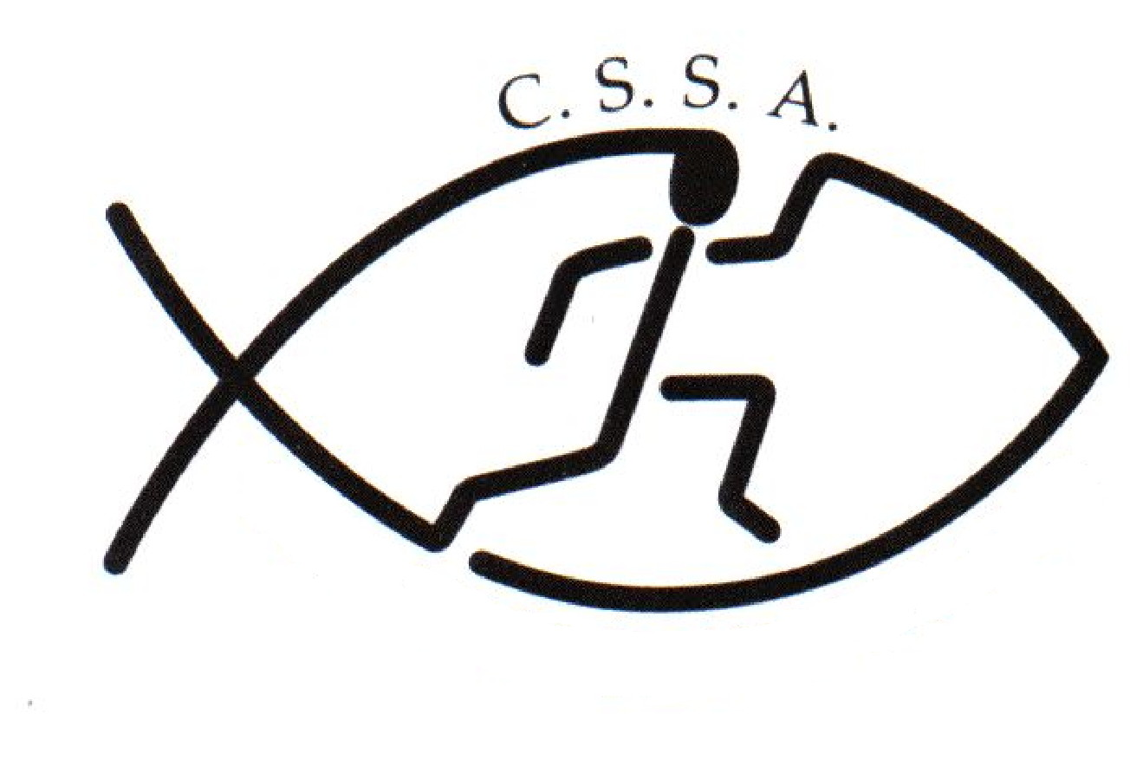
Risk Assessment Hazard Checklist – Student Activities
Event | CSSA Wag & MAG State Gymnastics | Assessment Date
Assessed By | Linda Heslehurst | Date

Locations | Sydney Gymnastic Centre - Rooty Hill | Activities
 | 12 N Parade, Rooty Hill NSW 2766 |  | Gymnastics WAG & MAG Levels
 | http://sgac.com.au/

Hazard |  | Risk |  | Risk  Low/Medium/High |  | Control Measures
 | Teacher/  Instructor  Qualifications  and Experience |  | Teacher/ Instructor  Qualifications and Experience  – non qualified teachers with not  enough experience |  | Low | - The teacher/instructor must have appropriate expertise and/or training in the teaching/coaching of gymnastics.  - A teacher must be present who has recognised current training in emergency care.
 | Supervision |  | Supervision – not  Supervising all activities  that are occurring  adequately |  | Low | - Principals and organising teachers must take into account such factors as age, experience, maturity of students, nature of the activity and experience of adult supervisors when arranging supervision and instruction.  - The instructor must be positioned so that all the activities, including circuit work, can be appropriately supervised.  - Where an adult other than a teacher is engaged to provide instruction, a teacher must be present to take overall responsibility.
 | People & organisational hazards |  | Lack of information, training or instruction: injury |  | Low | - Information relating to the CSSA State Gymnastics Competition. ie. rules/regulations has been sent out to all CSSA schools via email. This information can also be obtained from the CSSA website : www.cssa.net.au. The CSSA Code of Conduct can also be downloaded from the website. Schools are responsible for preparation of gymnasts ie train their students to an acceptable standard & have a good understanding of the rules/regulations prior to the competition.
 |  |  | Poor activity planning or preparation : injury  Poor activity delivery or organisation: injury |  | Low | - The convener has considerable experience organising gymnastic competitions and leading groups in similar environments. The CSSA State Gymnastics Competition will be coordinated by Mrs Amanda Butterworth: CSSA Assistant Executive Officer and Jodi Grant – Accredited Gymnastics Coach. Accredited judges will also be on hand.
 |  | Ignorance of rules and/or procedures: injury  Unsafe behaviour or attitude: injury  Poor safety control from group leaders: injury  Poor safety awareness from participants: injury |  | Low |  | - Information relating to the CSSA State Gymnastics Competition ie. rules/regulations has been sent out to all CSSA schools competing in the event via email. This information can also be obtained from the CSSA website : www.cssa.net.au.  - The CSSA Code of Conduct can also be downloaded from the website.  - CSSA recommend schools download the “CSSA Safety in Sports Guidelines” & refer to CSSA Handbook Gymnastics Safety Guidelines: http://www.cssa.net.au/index.php/handbook  - School team coaches/manager are responsible for their own team members.
Other hazards |  | Transport to and from your activity |  | Low |  | - Responsibility is with the students school and or parents.
 |  | Food Poisoning |  | Low |  | - A canteen will be available for students to purchase food & drink. All care has been taken to ensure proper control & handling procedures are followed. Purchasing food at these outlets is done at their own risk.
 |  | First Aid |  | Low |  | - First Aid and equipment provided and checked by trained personnel
 |  | Child Protection |  | Low |  | - All staff present at the event are understood to have undergone Working With Children check with by Individual Schools and Sydney Gymnastic Centre - Rooty Hill. Individual schools are required to supply sufficient supervision for their students throughout the entire event.
 |  | Dehydration/ Exhaustion Injury |  | Low/Medium |  | - The group rotations have been designed to ensure that competitors receive rest periods between apparatus. Individual schools to ensure that water bottles are available to all participants.
Equipment |  | Equipment – inappropriate clothing, improper use of equipment. |  | Medium |  | - Shorts or sports briefs and T-shirt or leotard should be worn.  - All equipment must be checked for safety prior to the competition.  - The equipment should be of suitable height and width and appropriately arranged for the specific activities. It should be placed parallel to walls and adequately spaced to facilitate supervision.  - Appropriate and adequate matting must be provided under and around all equipment to the point of likely projection. Ensure mats do not move out of position.  - Matting must not overlap. Mats must be joined, with no ridges. Where possible, velcro-edged mats should be used. Mats with holes must not be used.  - A well-equipped medical kit must be readily available.  - Gymnasts will not be permitted on equipment without direct supervision.
Venues |  | Venues – inappropriate flooring making activities unsafe |  | Low |  | - In all cases, adequate matting must be used under and around equipment and for floor activities.
General |  | General  - clothing  - jewellery  - size of groups |  | Low |  | - Students are to be instructed not to perform any unauthorised activities.  - Students must remove jewellery and other ornaments likely to cause injury.  - Students should be encouraged to keep fingernails and toenails short and long hair tied back.  - Where possible, ice should be available for the treatment of injuries.
Flexibility and  Injury |  | Flexibility and injury –  Inflexibility of students and  Injury therefore being caused |  | Medium |  | - warm-up prior to stretching  - stretch prior to and after work-outs  - stretch alternate muscle groups  - stretch gently and slowly  - never bounce or stretch rapidly  - stretch to the point with tension or discomfort but never pain  - do not hold the breath when stretching, breathe slowly and easily while stretching
Spotting |  | Spotting – injury  Through incorrect spotting needing too much spotting |  | Low/Medium |  | - Gymnasts will bring a coach or appropriate adult with them if they need spotting. Other coaches cannot be relied upon to spot
Tumbling |  | Tumbling – injury  Through incorrect technique |  | Medium |  | - For all skills which require more than one mat, firm velcro-joined mats or a continuous carpeted mat should be used.  - For advanced skills, a tumbling sprung floor.  - Only very basic skills are to be taught on concrete or asphalt surfaces and, only with appropriate matting
Beam |  | Beam – injury  Through incorrect technique and equipment |  | Medium |  | - Checks must be made to ensure that the height adjustment fitting is tight, the beam is securely attached to the legs and that the apparatus is stable.  - Students are to be instructed not to adjust the height of the beam without permission.  - Matting must be placed under the beam, around the leg supports, and on the landing area.

Change Rooms

CSSA recognises that children are particularly vulnerable in change rooms and that measures must be put in place to ensure that children are able to safely get changed without fear of intrusion or fear for their safety.

Generally, the expectation of CSSA is that Member School Staff and Member School Volunteers would appropriately supervise change rooms in accordance with NSW Department of Education guidelines. The same goes for CSSA Staff and CSSA Volunteers who may be required to supervise change rooms in the course of supervising CSSA Representatives at Non-CSSA Events.

Those guidelines are that change rooms should be supervised and supervisors should adhere to the following guidelines:

- give explicit instructions and guidelines for behaviour in change rooms
- set a routine for going into change rooms and keep to it
- announce to students when entering the change room and allow time for students to cover up, and
- do not stand in change rooms while students are changing as students have a right to privacy.

While the issue of a supervisor of either sex supervising the change rooms of both sexes poses some difficulties, some suggestions for supervisors in this situation include:

- give explicit rules about what is expected of students' behaviour in the change rooms
- ensure that students know that if there is an emergency you will enter the change room
- choose two student representatives to report to you about any problems in the change rooms
- ask the students to come out of the change room if there is any disturbance
- if for some reason the students remain in the change room seek a person of the appropriate sex to go in, and
- if there is an emergency, let students know you are coming in and give a warning to cover up before going in.

CSSA does not provide Personal/Accident Insurance Cover

As a competing school we are aware that all teachers/parents/volunteers that we send to a carnival or sporting event have
completed a “Working with Children” prohibited employment form

Risk Warning under section 5M of the Civil Liability Act 2002 (NSW)
on behalf of CSSA and its Member Schools
Sporting Activities
Christian Schools Sports Association (CSSA) administers and convenes CSSA inter-school sporting activities in which many students from Member Schools participate. Students participating in these sporting events take part in practice, trials and competitions.

CSSA and its Member Schools expect students to take responsibility for their own safety during sporting activities by wearing compulsory safety equipment, by thinking carefully about the use of safety equipment that is highly recommended and by behaving in a safe and responsible manner towards team members, opponents, spectators, officials, property and grounds. CSSA and its Member Schools also expect parents, spectators and other participants to behave in a safe and responsible manner, to comply with the CSSA Code of Conduct and to set a good example for the students.

While CSSA and its Member Schools take measures to make the sporting activities as safe as possible for participants, there is a risk that students can be injured and suffer loss (including financial loss) and damage as a result of their participation in these sporting activities, whether at training or in actual events.

Parents, spectators and officials could also be injured or suffer loss.

Injury can occur while the student, parent, spectator or official is engaging in or watching a sporting activity, or travelling to and from the event. The injury may result from a student's actions, the actions of others, the state of the premises or from equipment failure.

On some occasions, an injury can be serious (such as torn ligaments, dislocations, back injuries, concussion or broken bones). In very rare cases an injury can be life threatening or result in permanent disability. If a student, parent, spectator or official has a pre-existing injury, participating in a sporting activity could result in an exacerbation of that injury.

Students, parents, spectators and officials could also suffer loss as a result of their personal property being lost, stolen, damaged or destroyed.

CSSA does not provide Personal or Accident Insurance Cover.

