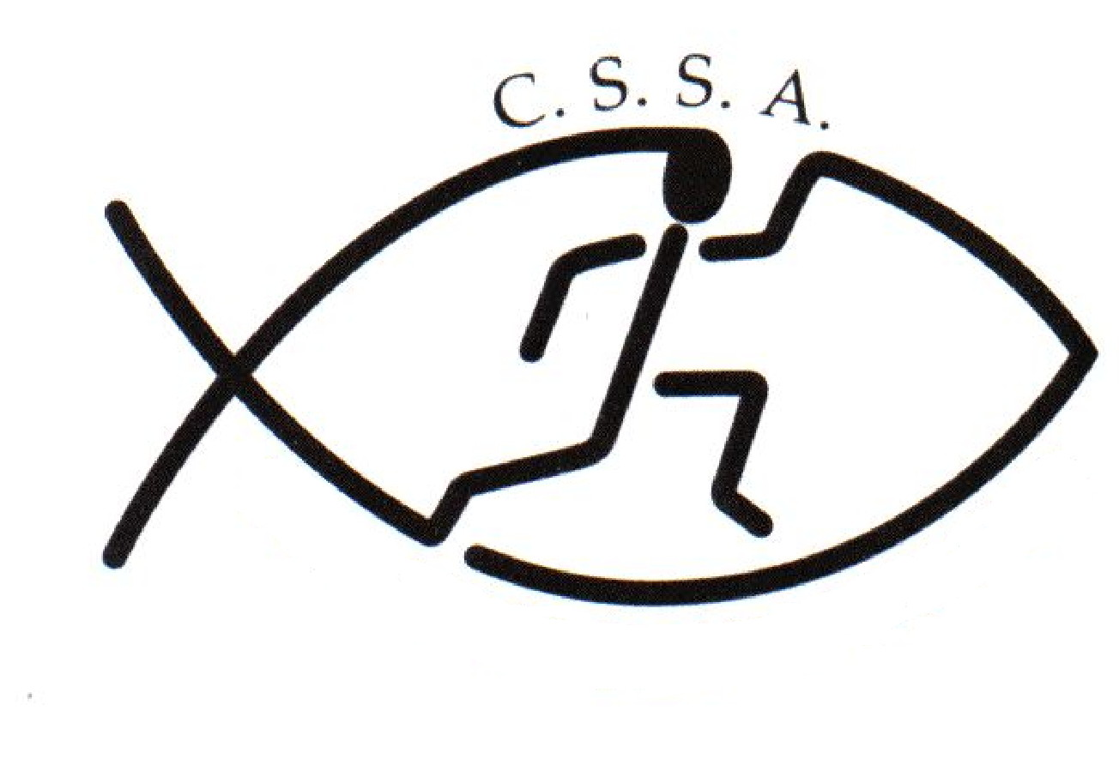
CSSA State X-Country Risk Assessment
Event | CSSA State Cross Country |  | Assessment Date
Assessed By | Linda Heslehurst |  | Approved By

Locations | The Sydney International Equestrian Centre |  | Activities | Cross Country running

1 | INDOOR HAZARDS |  |  | 5 | HAZARDS ON HILLS AND MOUNTAINS
1.1 | Inappropriate lighting |  |  | 5.1 | Slips & trips on grass, mud, rock | y
1.2 | Temperature |  |  | 5.2 | River crossings
1.3 | Insufficient or unsuitable space |  |  | 5.3 | Remote locations
1.4 | Untidiness – causing trip / fire hazard | y |  | 5.4 | Difficult communication – weather / distance | y
1.5 | Stairs – dark / steep / no handrail |  |  | 5.5 | Falling debris
1.6 | Lack of fire escapes / extinguishers / procedures |  |  | 5.6 | Extra work imposed by terrain type / angle
1.7 | Slip / trip / fall hazards | y |  | 5.7 | Lack of shelter | y
1.8 | Inadequate ventilation |  |  | 5.8 | Separation of group members
1.9 | Inhalation of dust |  |  | 5.9 | Getting lost | y
1.10 | Poor surfaces for activities – slips / trips / impact |  |  | 5.10 | Falls from height
1.11 | Electrical hazards | y |  | 5.11 | Extremes of weather | y
2 | SPORTING ACTIVITY HAZARDS |  |  | 6 | PEOPLE & ORGANISATIONAL HAZARDS
2.1 | Uneven playing surface | y |  | 6.1 | Lack of information, training or instruction | y
2.2 | Playing surface too hard or soft |  |  | 6.2 | Poor activity planning or preparation | y
2.3 | Hard or sharp objects on pitch | y |  | 6.3 | Poor activity delivery or organisation | y
2.4 | Sliding on Astroturf or similar surface |  |  | 6.4 | Ignorance of rules and / or procedures | y
2.5 | Collisions / Conflict with surrounding objects or people | y |  | 6.5 | Unsafe behaviour or attitude | y
2.6 | Impact from sports equipment - Ball or Clubs |  |  | 6.6 | Lack of appropriate first aid equipment and experience | y
2.7 | Contact sport injury |  |  | 6.7 | Medical conditions of participants | y
2.8 | Personal injury – fracture / sprains / cuts | y |  | 6.8 | Poor safety control from group leaders | y
22.22 | USE BY UNTRAINED PERSONS NAUGHTY | YE |  | 6.9 | Poor safety awareness from participants
3 | HAZARDS ON COASTS & COASTAL WATERS |  |  | 6.11 | Lack of cooperation within group
3.1 | Falls from cliffs, piers, sea walls |  |  | 6.12 | Differing skill levels within group
3.2 | Struck by falling objects from cliff |  |  | 6.13 | Low level of physical fitness / strength | y
3.3 | Slips & falls on slopes / loose surfaces |  |  | 6.14 | Aggression between participants
3.4 | Quick sand & mud |  |  | 6.15 | Aggression from crowd / public | y
3.5 | Access problems due to steep angle of beach slope |  |  | 6.16 | Contact between participants increasing risk
3.6 | Collisions between water users |  |  | 2.22 | USE BY UNTRAINED ERSONS NAUGHTY | ES
3.7 | Swept away by wave surges |  |  | 7 | EQUIPMENT AND OTHER HAZARDS
3.8 | Being washed against rocks / piers |  |  | 7.1 | Crash handling
3.9 | Low water temperatures |  |  | 7.2 | Transport to and from your activity | y
3.10 | Communication problems from waves / swell / distance |  |  | 7.3 | Food poisoning | y
3.11 | Struck by objects in water |  |  | 7.4 | Hazardous substances
3.12 | Stranded by tides |  |  | 7.5 | Equipment with moving / hot parts
3.13 | Swept away by currents |  |  | 7.6 | Heavy equipment
3.14 | Rip tides |  |  | 7.7 | Electrical hazards from equipment | y
3.15 | Longshore drift |  |  | 7.8 | Noise from equipment
3.16 | Conflicts between beach users |  |  | 7.9 | Risk of trapping body / clothing in equipment
22.22 | UNTRAINED PERSONS NAUGHTY | YE |  | 7.10 | Inadequate environment for equipment operation
4 | HAZARDS ON STILL / MOVING WATER |  |  | 7.11 | Inadequate protective equipment
4.1 | Getting swept away from equipment or people |  |  | 7.12 | Equipment in unsuitable condition
4.2 | Collision with rocks in and to sides of rivers |  |  | 22.22 | USE BY UNTRAINED PERSONS NAUGHTY | YS
4.3 | Striking / trapping by submerged obstacles |  |  | 8 | OTHER HAZARDS SPECIFIC TO YOUR ACTIVITY
4.4 | Being dragged down by undertow |  |  | 8.1 | Venue does not meet safety standards | y
4.5 | Restricted or impossible access to / from water |  |  | 8.2 | Students/Spectators unfamiliar with emergency procedures | y
4.6 | Access problems – rescue / getting kit into water |  |  | 8.3 | Child Protection | y
4.7 | Falls from drops in level at weirs / waterfalls |  |  | 8.4 | Inadequate Supervision | y
4.8 | Getting out of depth |  |  | 8.5 | Sun sense/Dehydration/Exhaustion | y
4.9 | Low water temperature |  |  | 8.6
4.10 | Separation from other people |  |  | 8.7
4.11 | Slips / trips on steep banks or uneven surfaces |  |  | 8.8
4.12 | Difficult communications |  |  | 8.9
4.13 | Remote locations |  |  | 8.10

Risk Assessment – Student Activities

Club/Society Name | Christian Schools Sports Association | Number of persons involved
Nature of Activity | State Cross Country | Frequency of Activity Weekly | 1/year

Assessed By | Linda Heslehurst | Date

Hazard Ref. | Potential Effect | Existing Controls in Place | Risk Rating | Further Controls Required? | Final Risk Rating
 | Recording Room
1.4 | Untidiness – causing trip / fire hazard | Equipment not in use to be packed away at the back of the room in an area that is not a thoroughfare. | 5 | None required | 5
1.7 | Slip / trip / fall hazards | Cables from computers, sound equipment to run along front edge of tables away from recorders & competitors | 5 | None Required | 5
1.11 | Electrical hazards | All outdoor electrical cables, power plugs or power boards to be covered to avoid moisture entering the connection | 3 | All connections or power boards are to be covered by plastic and off the ground when connected | 4
 | Course
2.1  2.8 | Uneven playing surface  Personal injury – fracture/sprains/cuts | The State X-Country will be run at an outdoor venue that is regularly checked & maintained by The Sydeny International Equestrian Centre.  The running surface can be uneven in spots. Competitors are required to wearing adequate footware appropriate for the sport & are encouraged to strap their ankles & knees to help prevent sprains etc. | 3 | None Required | 3
2.3 | Hard or sharp objects on pitch | A safety & venue audit will be conducted prior to the commencement of the state X-Country. Any sharp objects will be removed or a warning sign placed near any potential danger. | 4 | None Required | 4
2.5 | Collision with surrounding objects or people | Competitors are given clear instruction by the starter not to push or shove at the beginning of the race when it is the most congested. Competitors are required to conduct themselves in accordance with the rules of the event and the CSSA Code of Conduct.  If injury does occur there is qualified first aid trainers on hand. | 3 | School Sports Coordinators are required to make their students aware that congestion that can exist at the start of a race and encourage caution. | 4
5.1 | Slips and trips on grass, mud, rock | The course is kept in good order by staff at the The Sydeny International Equestrian Centre. During the Course set up the day before the event any hazards are marked or roped off with safety tape | 3 | Course checked on morning of event for any new trip hazards, obvious loose or dangerous objects removed, students reminded of the need to watch where they place their feet | 4
5.4 | Difficult Communication on the course | Course officials to carry a mobile phone with the carnival convener & 1st Aid contact details. | 3 | All check points to have a first aid kit. | 5
5.9 | Compettors getting lost on the course | The course is marked with arrows approx 10 - 20 meters apart and barrier tape where there is a more than one option of track. Course officials are stationed at all points of ambiguity on the course.  Students will be able to walk the course prior to the commencement of each session. | 5 | None Required | 5
5.7  5.11 | Lack of shelter  Extremes of Weather | Schools are encouraged to remind students to bring changes of clothes and be prepared for all conditions.  A small covered Grand Stand is provided for adult spectator seating. Schools are required to bring suitable shade shelters to ensure that their students have adequate protection from the weather. If the weather is inclement, warm clothing and rain protection will be required. The wind can be very fierce at The Sydeny International Equestrian Centre.  Course to be checked regularly by officials to determine the need to shut down any sections that become too slippery in wet weather | 4 | The state convener will monitor conditions in relation to heat, storms and adverse weather. The course may be altered or races postponed, suspended or cancelled as required. | 4
6.1 | Lack of information, training or instruction | All schools are emailed a map of the course and distances to be completed. Competitors can walk the course prior to the primary & secondary session.  Students are required to have qualified through their school cross country in order to prove their fitness  Information relating to the State X-Country Carnival ie. rules/regulations has been sent out to all CSSA schools via email. This information can also be obtained from the CSSA website : www.cssa.net.au  The CSSA Code of Conduct can also be downloaded from the website. Schools are responsible for preparation of runnerss ie train their students to an acceptable standard & have a good understanding of the rules/regulations prior to the meet | 5 | None Required | 5
6.2 | Poor activity planning or preparation | The state convener & course set up team have considerable experience organising x-country carnivals and leading groups in similar environments. The state X-Country carnival will be coordinatoed by CSSA Executive Officer : Linda Heslehurst.  Pre event meetings to check and double check planning | 5 | None Required | 5
6.3 | Poor activity delivery or organisation | Course explanation to all participants to explain details of course and dangers on course. Competitors can walk the course prior to the primary & secondary session.  Marshalls and Starter to give clear instructions to all runners on safety at the beginning and to point out any particular dangers in the close nature of the start.  All course officials to carry first aid equipment and mobile phone. | 5 | Have all marshals/officials briefed on safety procedures and rules for the safe running of the carnival | 5
6.4  6.5 | Ignorance of rules and /or procedures  Unsafe behaviour or attitude | Procedures and rules outlined in the program. Information relating to the State X-Country Carnival ie. rules/regulations has been sent out to all CSSA schools via email. This information can also be obtained from the CSSA website : www.cssa.net.au  The CSSA Code of Conduct can also be downloaded from the website.  Team managers/individual school are responsible for their own team members. | 4 | All schools to be reminded of the code of conduct and expectation at CSSA events such as no ball games  Announcements made regularly throughout the day reminding those in attendance of carnival regulations and rules | 5
6.6 | Lack of appropriate first aid equipment and experience | Qualified first aid team will be on hand. | 3 | All course officials are required to supply & carry a 1st Aid Kit | 5
6.7  6.13 | Medical conditions of participants  Low level of physical fitness / strength | If students are asthmatic they must carry their medication at all times.  Students are required to complete school cross country over a similar distance. All races pass the finish line throughout the race giving students who are struggling to pull out or seek assistance. | 4 | Course officials in remote sections of course wil have contact details of First Aid officer and mobile phone | 5
6.15 | Aggression from crowd / public | All attendees are reminded of the CSSA Code of Conduct and are refered to team management when there is an issue or dispute | 5 | None Required | 5
7.2 | Transport to and from your activity | Responsibility is with the students school and or parents. | 5 | None Required | 5
7.3 | Food Poisoning | A canteen will be available for students to purchase “Fast/Take Away” food & drink. All care has been taken to ensure proper control & handling procedurers are followed.  Purchasing food at these outlets is done at their own risk. Spectators & competitors are recommended to bring their own food & drink to the venue. | 5 | None Required | 5
7.7 | Electrical hazards from Equipment | All electrical cables to be covered where they pass a thoroughfare | 5 | None required | 5
8.1 | Venue does not meet safety standards : Injury | The Sydeny International Equestrian Centre to provide documentation | 5 | None required | 5
8.2 | Students/Spectators unfamiliar with emergency procedures : Injury | Emergency procedures announced at the start of the carnival and at 11.30am | 5 | None required | 5
8.3 | Child Protection | All staff present at the event are understood to have undergone Working With Children checks through the The Sydeny International Equestrian Centre or Individual Schools. | 4 | The venue is open to the public, therefore all schools are to provide adequate supervion of their students all day – particularly in the grandstand & canteen/toilet areas | 5
8.4 | Inadequate Supervision | Individual schools are responsible for their own teams – including all transport organisation | 5 | None required | 5
8.5 | Sunsense/Dehydration/ Exhaustion | CSSA to provide sunscreen for competitors at First Aid station. Schools reminded to provide sunscreen and students to bring hats.  Announcements throughout the day reminding students to wear a hat and apply sunscreen regularly if the day is sunny.  Students required to bring their own water to drink before and after races. A water staion will be provided at the finish line for all competitors. | 4 | It is highly recommended that competitors increase their water intake several days before the carnival and drink at least 4 large glasses of water the morning of the carnival. This will hydrate their body cells and help avoid dehydration.  Participants are encourage to carry water when running if they require it  Regular announcements about being well hydrated before the race and after the race before drinking sugar drinks. | 5

RISK ASSESSMENT MATRIX

SEVERITY | LIKELIHOOD  How likely is that to be that bad?
How severely could it hurt someone or how ill could it make someone? | Very likely  Could happen  Any time | Likely  Could happen sometime | Unlikely  Could happen, but very rarely | Very unlikely  Could happen, but probably never will
Kill or cause permanent disability or ill health | 1 | 1 | 2 | 3
Long term illness or serious injury | 1 | 2 | 3 | 4
Medical attention and several days off school/work | 2 | 3 | 4 | 5
First aid needed | 3 | 4 | 5 | 6

The numbers indicate how important it is to do something-

1 top priority – do something immediately
6 low priority – do something when possible

Change Rooms

CSSA recognises that children are particularly vulnerable in change rooms and that measures must be put in place to ensure that children are able to safely get changed without fear of intrusion or fear for their safety.

Generally, the expectation of CSSA is that Member School Staff and Member School Volunteers would appropriately supervise change rooms in accordance with NSW Department of Education guidelines. The same goes for CSSA Staff and CSSA Volunteers who may be required to supervise change rooms in the course of supervising CSSA Representatives at Non-CSSA Events.

Those guidelines are that change rooms should be supervised and supervisors should adhere to the following guidelines:

- give explicit instructions and guidelines for behaviour in change rooms
- set a routine for going into change rooms and keep to it
- announce to students when entering the change room and allow time for students to cover up, and
- do not stand in change rooms while students are changing as students have a right to privacy.

While the issue of a supervisor of either sex supervising the change rooms of both sexes poses some difficulties, some suggestions for supervisors in this situation include:

- give explicit rules about what is expected of students' behaviour in the change rooms
- ensure that students know that if there is an emergency you will enter the change room
- choose two student representatives to report to you about any problems in the change rooms
- ask the students to come out of the change room if there is any disturbance
- if for some reason the students remain in the change room seek a person of the appropriate sex to go in, and
- if there is an emergency, let students know you are coming in and give a warning to cover up before going in.

CSSA does not provide Personal/Accident Insurance Cover

As a competing school we are aware that all teachers/parents/volunteers that we send to a carnival or sporting event have completed a “Working with Children” prohibited employment form

Risk Warning under section 5M of the Civil Liability Act 2002 (NSW)
on behalf of CSSA and its Member Schools
Sporting Activities
Christian Schools Sports Association (CSSA) administers and convenes CSSA inter-school sporting activities in which many students from Member Schools participate. Students participating in these sporting events take part in practice, trials and competitions.

CSSA and its Member Schools expect students to take responsibility for their own safety during sporting activities by wearing compulsory safety equipment, by thinking carefully about the use of safety equipment that is highly recommended and by behaving in a safe and responsible manner towards team members, opponents, spectators, officials, property and grounds. CSSA and its Member Schools also expect parents, spectators and other participants to behave in a safe and responsible manner, to comply with the CSSA Code of Conduct and to set a good example for the students.

While CSSA and its Member Schools take measures to make the sporting activities as safe as possible for participants, there is a risk that students can be injured and suffer loss (including financial loss) and damage as a result of their participation in these sporting activities, whether at training or in actual events.

Parents, spectators and officials could also be injured or suffer loss.

Injury can occur while the student, parent, spectator or official is engaging in or watching a sporting activity, or travelling to and from the event. The injury may result from a student's actions, the actions of others, the state of the premises or from equipment failure.

On some occasions, an injury can be serious (such as torn ligaments, dislocations, back injuries, concussion or broken bones). In very rare cases an injury can be life threatening or result in permanent disability. If a student, parent, spectator or official has a pre-existing injury, participating in a sporting activity could result in an exacerbation of that injury.

Students, parents, spectators and officials could also suffer loss as a result of their personal property being lost, stolen, damaged or destroyed.

CSSA does not provide Personal or Accident Insurance Cover.

CROSS COUNTRY Date:

Level of Competition (tick appropriate) |  |  | Intra School |  |  | Inter School
Year level/s (tick appropriate)
Infants ( K-2) |  | Junior Primary (Yrs 3-4) |  |  |  | Senior Primary (Yrs 5-6)
Junior High (Yrs 7-8) |  | Middle High (Yrs 9-10) |  |  |  | Senior High (Yrs 11-12)

General
 | Yes | No | NA
Permission has been obtained from parents/guardians for all students participating
Adequate teachers are attending providing appropriate levels of supervison for competitors and spectators.
Parents have been notified of location of venue, transport arrangements and time involved
First Aid Kit Available
Water is available for students at the venue
Ice is available
Students have been advised of personal sun protection requirements
Students suffering from Asthma have been advised to carry their puffer to all events
Staff issued with infectious diseases policy
Form provided for record of injuries/incidents
Access available for emergency vehicle
A Risk Assessment has been completed

Participants & Officials

All officials clearly briefed
Officials easily identified by appropriate clothing
Officials are located at appropriate intervals along the course
Drinks are available at end of run

Equipment / Grounds

Course is appropriate to age group and ability.
The starting area is of sufficient width and the first 200-300m is straight and free of obstacles
Course clearly marked
There is vehicle access to all areas of the course
Public facilities and buildings which are to be used have been checked
Appropriate spectator areas are clearly marked

Environmental

Weather conditions appropriate for the safe conduct of the event

